**Sponsorship Packet**

Upcoming Session: July 15th – 19th

Shaler North Hills Library

www.chesspire.org

* What is Chesspire?
* Benefits of Sponsoring
* Sponsorship Tiers

**2024**

**About**

Chess is an art of intellect that has a profound impact beyond the game board. At Chesspire, we believe it can transform lives and shape futures. It nurtures decision-making, problem-solving, and critical thinking skills, empowering young minds to navigate life's complexities. Chess also cultivates virtues of patience, perseverance, and resilience, fostering personal growth and character development. Our STEM camps teach the sciences in fun and interactive way to develop mastery over the content while focusing on practical application: whether that be through mock Olympiads to prepare for science competitions or our 1-on-1 mentoring, teaching students how to use neuroscience to reach their goals.

Chesspire is a community where dreams are nourished, friendships flourish, and a sense of belonging thrives. Your sponsorship can help us ignite the brilliance within countless children, ensuring that no dream goes unfulfilled. **Together, let us shape a brighter future, one move at a time.**

**What impact does Chess/STEM hold?**

We are **Chesspire**, a 501(c)(3) nonprofit organization dedicated to inspiring the next generation of problem-solvers to aspire through chess and STEM education. We started with a chess camp in our local community of Northern Pittsburgh, but have since expanded internationally and expanded our programs to teach problem-solving skills through a variety of curricula.

Chesspire is not merely a camp; it is a community united by a common passion for intellectual growth and camaraderie. Within our week-long program, friendships are forged, mentorship blossoms, and dreams are nurtured. We are committed to fostering an environment where every child feels seen, heard, and valued. **Together, we celebrate diversity, embracing the unique perspectives and talents that each young mind brings to the table.**

Upcoming Session: July 15th – 19th

Shaler North Hills Library

www.chesspire.org

Session 1: June 12th – 16th, 2023

North Allegheny School District

chesspire.org

**Sponsor Benefits**

**Supporting the Community**

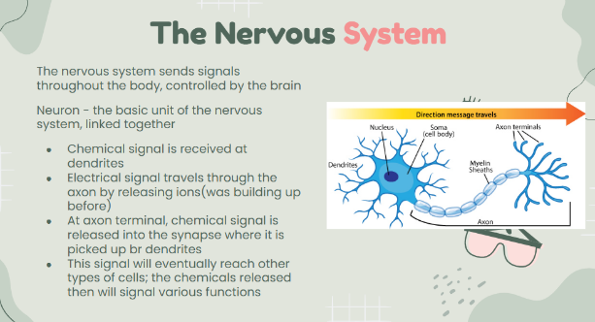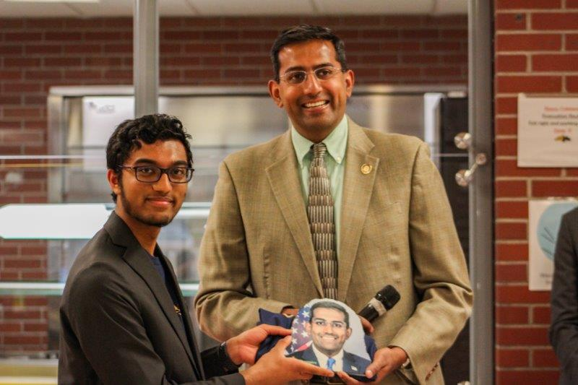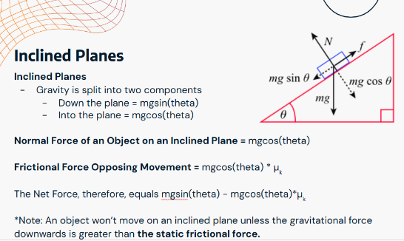

**Chesspire offers the chance to sponsor a pathway seminar, empowering participants to delve into specific chess and STEM topics.** Projects aligned with the pathway can win awards from your company. Engage with us by sending a representative to teach and judge pathway projects. Join Chesspire as a pathway sponsor and inspire the next generation of chess enthusiasts while gaining recognition for your support.

**Pathways**

Chesspire, a community-driven initiative, invites your company to support our cause. Through our free camps, we provide underprivileged kids with access to the transformative benefits of chess and STEM. Your sponsorship allows us to provide essential resources, such as T-shirts, chess memberships, and meals, ensuring every participant can fully engage. **Join us in fostering a nurturing chess and STEM community and empowering the next generation. Together, let's make a meaningful difference through the captivating worlds of chess and STEM.**

**Company Exposure**

Chesspire presents valuable sponsorship opportunities for your company to expand its reach. **Your company logo will be prominently featured on our t-shirts, marketing materials, website, and press releases, ensuring widespread visibility.** As a sponsor, you can also take advantage of additional benefits. You can send a representative to deliver a compelling keynote speech, connecting with our enthusiastic participants. We would love your sponsor to also distribute branded merchandise, leaving a lasting impression. Join us in unlocking the potential to elevate your brand through the captivating world of chess and STEM.

Upcoming Session: July 15th – 19th

Shaler North Hills Library

www.chesspire.org

Session 1: June 12th – 16th, 2023

North Allegheny School District

chesspire.org

**STEM Division**

**2024 Summer Plans!**

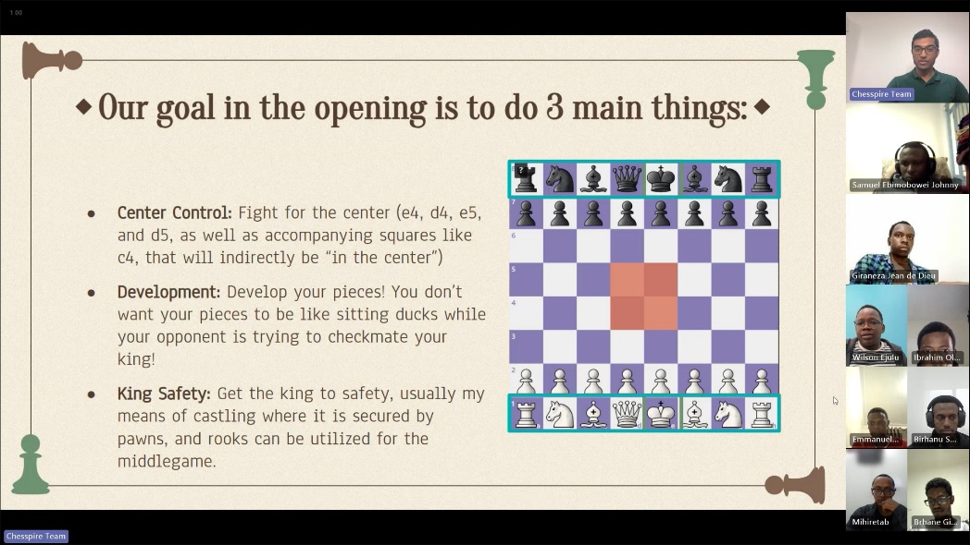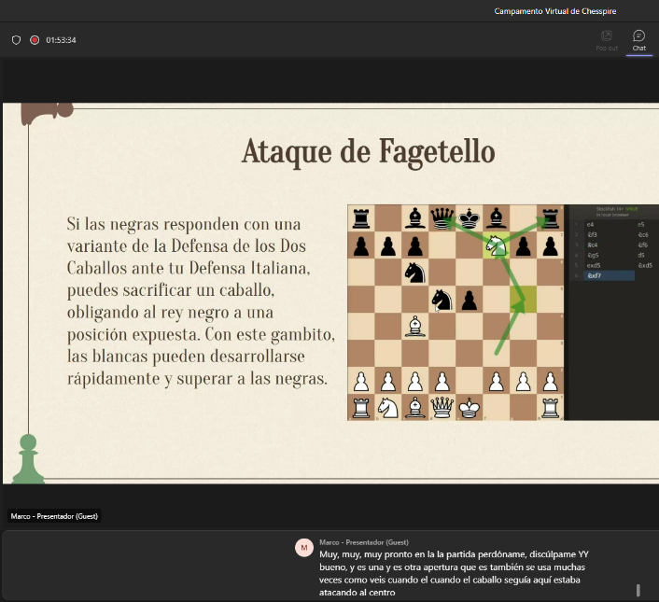

Upcoming Session: July 15th – 19th

Shaler North Hills Library

www.chesspire.org

Since our last camp in December, Chesspire has opened divisions ranging from our CMU-Africa Chapter in Rwanda to our Latin America chapter in Colombia (conducted entirely in Spanish). **We’re dedicated to providing our valuable knowledge to everyone, no matter the language or barriers.**

**Other Chapters**

Every year has a different focus in the area of STEM. Last year, we conducted a rigorous Olympiad training camp that prepared students for national science competitions. This year, we gave our camp a practical twist, focusing on using science knowledge to improve life skills. Students will have the opportunity to learn neuroscience and cognitive science principles to enhance their study habits, focus, planning, and overall life skills. These skills will help them succeed in any career they choose. The workshop includes a small competition and individual mentoring sessions to help them achieve their goals. This **in-person** camp will be run parallel to our July chess camp at Shaler Library.

Upcoming Session: July 15th – 19th

Shaler North Hills Library

www.chesspire.org

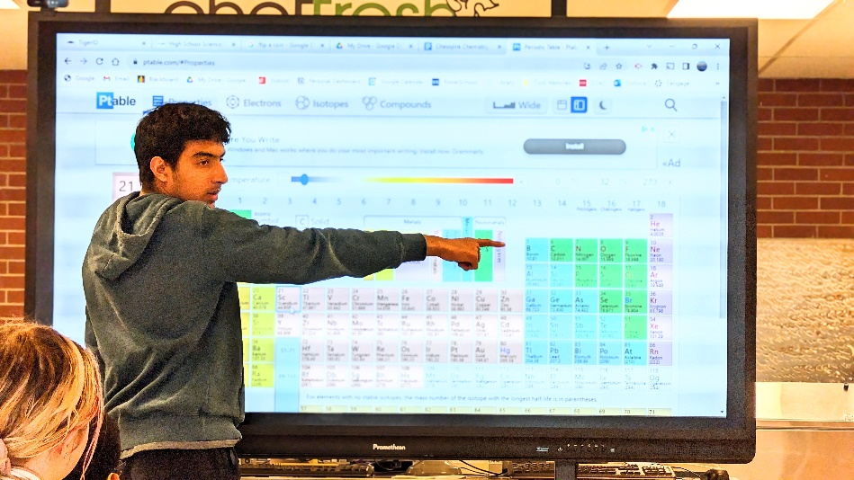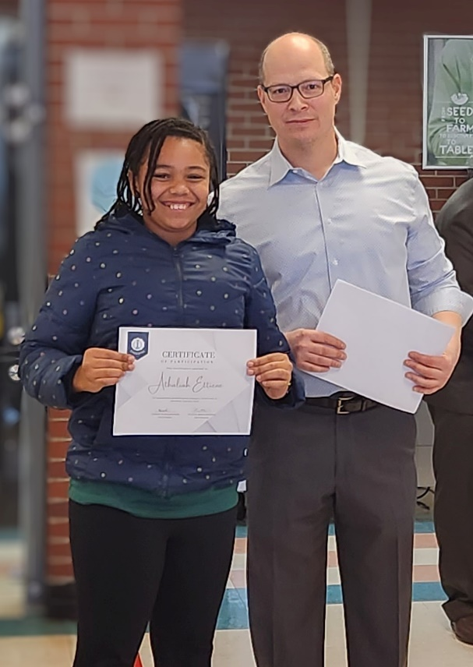

**Photos!**

Upcoming Session: July 15th – 19th

Shaler North Hills Library

www.chesspire.org

|  |  |  |  |  |
| --- | --- | --- | --- | --- |
|  | **Bronze** | **Silver** | **Gold** | **Executive** |
| Money Bag on Samsung One UI 5.0  Contribution | **$100-500** | **$500-1000** | **$1000-2000** | **$2000+** |
| Globe with Meridians on Google Noto Color Emoji 15.0  Website | Company Name in Press Releases  Small Logo on Website | Medium Logo on Website | Large Logo on Website | Company Name, Logo, & Brief Statement |
| Page Facing Up on Google Noto Color Emoji 15.0  Press Release |  | Company Name, Logo, & Brief Statement | Company Name, Logo, & Brief Statement | Dedicated Section on Website |
| Speech Balloon on Google Noto Color Emoji 15.0  Ceremony | Mention & Logo During Opening Ceremony | Short Presentation – Opening Ceremony | Opportunity to Be Panel Speaker at Event | Opportunity to Be Keynote/Closing Speaker |
| T-Shirt on Google Noto Color Emoji 15.0  Merchandise | Small Mention | Distributed company merchandise/swag | Distributed company merchandise/swag | Distributed company merchandise/swag |
| Trophy on Google Noto Color Emoji 15.0  Prize | No prize |  | Sponsored Prize  No prize | Sponsored Prize |

**Sponsorship Tiers**

**Other Sponsorship Opportunities**

We encourage all Chesspire sponsors to send representatives from your company to the event.

We are also happy to distribute any company merchandise items (stickers, t-shirts, pens, company promo items, etc.) to our participants.

Our team is very flexible. We would love to discuss any other sponsorship ideas you might have. Keep in mind that not all contributions need to be monetary, as we are also looking for discounts on food and prizes.

Upcoming Session: July 15th – 19th

Shaler North Hills Library

www.chesspire.org

Please contact us at [sponsorships@chesspire.org](mailto:sponsorships@chesspire.org) if you are interested in sponsoring, or have any questions!